Comparison of similar projects and materials used.

Autonomous RC Car using Arduino: A high school student decided to create an autonomous RC car for his capstone project in Engineering Design, Development and Robotics course. It ended up winning an award for best autonomous vehicle at a high school STEM expo.

Instead of creating a vehicle from scratch he decided to use a car that was already paired with an Arduino Uno RedBoard. The Arduino was selected specifically because it is easy to program and use. He also mentions that for the motor he was using a Redcat Racing 03061 Splash-Resistant ESC with a brushed motor. The ESC was already working with a controller that came with the vehicle. However, he did not test this with a brushless motor since the school did not have one available.

The car collects data from 5 HC-SR04 Ultrasonic sensors which then send the data back to the Arduino, where it makes decisions on how to move. The Arduino then controls the steering servo and motor accordingly. The program only uses the standard Arduino servo library and no other additional libraries were involved.

Materials used

* (1) Arduino Uno Redboard Cost: $19.95
* (1) Breadboard - for this project, he took the +/- rail from one breadboard and used another, smaller breadboard. Any size will do. Cost: $5.90
* (5) HC-SR04 Ultrasonic Sensors Cost: $11.98
* (1) Potentiometer - used to control the speed of the car CostP: $12.98
* (20) Female-Male Dupont wires - I highly recommend having more to use as extenders for other wires if needed Cost: $10.99
* Soldering Iron with solder Cost: Cheapest one I saw on Amazon for a full kit $29.99
* Arduino Power Supply - in this case,he used (6) 1.2v AA batteries wired in series. External phone and tablet power banks will also work well when plugged into the USB port. Cost $6.49
* Tape, hot glue, and/or any other items used to fasten items together Cost in total: around $10
* (1) Toggle Switch (optional -- to turn the Arduino on and off) Cost: $8.03

ROI/Breakeven Cost: N/A was used primarily for a capstone project for a high school student.

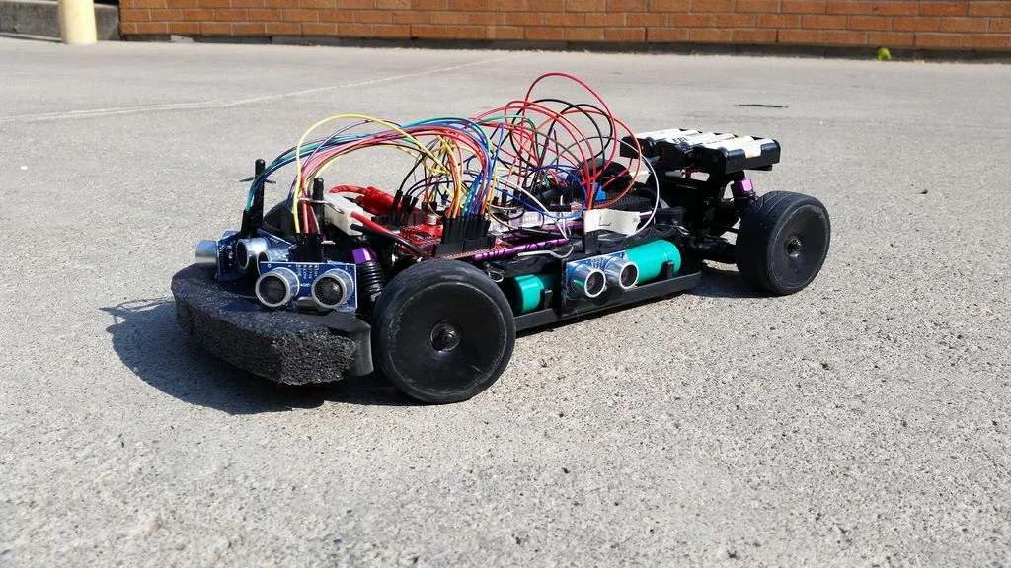

MIT RACECAR Project

MIT participated in creating their own version of an autonomous vehicle although they are utilizing NVIDIA’s Jetson platform. The course description stated that the students will design and implement perception and planning algorithms for cars that can navigate quickly through complex environments. Individuals will be assigned into 6 groups with each team given one RC race car which is powered by an NVIDIA Jetson embedded supercomputer, an inertial measurement unit, a visual odometer, a laser scanner, and a camera. The class also taught the students how to use the Robot Operating System(ROS) on the NVIDIA platform while interfacing with sensors and actuators.

Materials Used

* The R/C Car – Traxxas Rally 7407
* On board computer – NVIDIA Jetson TK1
* 2D LIDAR – Hokuyo UST-10LX
* Camera – Point Grey Firefly MV
* Battery for electronics – Energizer XP8000AB

A couple of the electronic components come from Sparkfun, specifically an opto-isolator board and Razor 9DOF IMU.

The structure of the vehicle is augmented by acrylic platforms to mount the sensors and electronics, along with some 3D printed parts for the overall structure itself.

An optical flow visual odometer, a PX4FLOW, is mounted on the top platform. However in practice the device was not used very much because it did not provide sufficient resolution for the environment where the cars were operating.

There is one custom built electronic part on the vehicle. A custom circuit board connects to the Jetson J3 header which adds access to the Jetson GPIO signals, adds a real time clock, and an opto-isolator. The GPIO access is used to send PWM signals to the vehicle’s servos and motors.

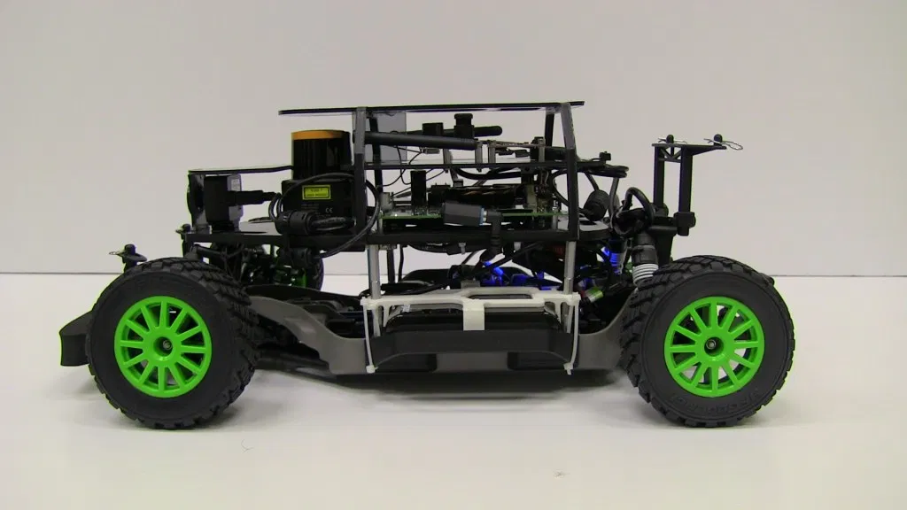

Bridgewater State University COMP 502 Project

In 2015 Bridgewater State University created an autonomous RC car that reacts with stop signs, traffic signals and navigates a track.

The system consisted of three different subsystems: an input unit(camera, ultrasonic sensor), a computer and a RC unit. The university ended up using a Raspberry Pi model B+ board attached with a pi camera and a HC-SR04 ultrasonic sensor to collect data. Two programs ran concurrently on the Pi for streaming color video and ultrasonic sensor data to the computer via Wi-FI. The computer then receives the data from the PI, uses neural network training and prediction, object detection, distance measurement and sends instructions to the Arduino via USB. A TCP server is also run on the computer to receive images and data from the Pi. Each one of these images are then added to an array.

RC Car Control Unit

The RC car used in this project has an on/off switch type controller. When a button is pressed, the resistance between the relevant chip pin and ground is zero. Thus, an Arduino board is used to simulate button-press actions. Four Arduino pins are chosen to connect four chip pins on the controller, corresponding to forward, reverse, left and right actions respectively. Arduino pins sending LOW signal indicate grounding the chip pins of the controller; on the other hand sending HIGH signal indicates the resistance between chip pins and ground remain unchanged. The Arduino is connected to the computer via USB. The computer outputs commands to Arduino using serial interface, and then the Arduino reads the commands and writes out LOW or HIGH signals, simulating button-press actions to drive the RC car.

Results

Prediction on the testing samples returns an accuracy of 85% compared to the accuracy of 96% that the training samples returns. In actual driving situations, predictions are generated about 10 times a second (streaming rate roughly 10 frames/s).

Overall, the RC car could successfully navigate on the track with the ability to avoid front collision, and respond to stop signs and traffic lights accordingly.

<https://youtu.be/BBwEF6WBUQs>